

A

PROJECT REPORT

ON

**“SOLAR BASED SMART GRID WIREMAN SAFETY”**

1. **PRANAV L. SADAFAL (174163)**
2. **RINKU R. PAWAR (174162)**
3. **GAURI R. JADHAV (174161)**
4. **DIVYA V. VYAS (174158)**
5. **GANESH H. SHINGANE (174160)**
6. **KALPESH M. CHAUDHARI**
7. **DIPALI S. BOKAD (164139)**

Under the guidance of

**Prof . MAHESH P. BODKE**

**Department of Electrical Engineering**

GOVERNMENT POLYTECHNIC, NASHIK

(An Autonomous Institute of Govt. of Maharashtra)

New Building Campus, Samangaon road, Nasik Road-422101

**October, 2019-20**

**CERTIFICATE**

Certified that this seminar report titled

**“ SOLAR BASED SMART GRID WIREMAN SAFETY ”** presented by

1. PRANAV L. SADAFAL
2. RINKU R. PAWAR
3. GAURI R. JADHAV
4. DIVYA P. VYAS
5. GANESH K. SHINGANE
6. KALPESH S. CHAUDHARI
7. DIPALI S. BOKAD

is approved for submission by us, Certified further that in partial fulfilment of requirement of Diploma in **Electrical Engineering** from Government Polytechnic, Nasik (An Autonomous Institute of government of Maharashtra) during the academic Year 2019 -2020 is record of their own work carried under my guidance.

**GUIDED BY HOD**

(Prof. Mahesh P. Bodke) (Prof. Rajesh U. Shelke)

**PRINCIPAL**

(Prof. D. P. Nathe)

**DATE:**

**PLACE:** Nasik

**ACKNOWLEDGEMENT**

We would like to place on record my deep sense of gratitude to my guide Prof. Mahesh Bodke, Dept. of Electrical Engineering, Government Polytechnic Nashik, for his generous guidance, help and useful suggestions.

We express our sincere gratitude to Prof. R. U. Shelke, Professor and Head, Dept. of Electrical Engg., Mrs. D. R. Kirtane, Mrs S. S. Umare, Mr S. S. Ashtaputre, Mrs S. S. Bhusare, Department of Electrical Engineering, Government Polytechnic Nasik, for their stimulating guidance and constructive suggestions to improve quality of dissertation work.

We also wish to extend our thanks to faculty members of Dept. of Electrical Engineering, Government Polytechnic Nasik, for attending my seminar and for their insightful comments ad constructive suggestions to improve the quality of this seminar work.

We acknowledge our sincere thanks to Prof. D. P. Nathe, Principal, Government Polytechnic Nasik, for providing me infrastructural facilities to work in, without which this work would not have been possible.

Name of Students,

Mr. PRANAV L. SADAFAL

Ms. RINKU R. PAWAR

Ms. GAURI R. JADHAV

Ms. DIVYA P. VYAS

Mr. GANESH K. SHINGANE

Mr. KALPESH S. CHAUDHARI

Ms. DIPALI S. BOKAD

**INDEX**

|  |  |  |  |
| --- | --- | --- | --- |
| **SR.NO.** | **SUBTOPICS** | **DESCRIPTION** | **PAGE NO.** |
|  |  | **Certificate** |  |
|  |  | **Abstract** |  |
| **1.** |  | **Introduction** | **7** |
| **2.** |  | **Literature review** | **9** |
| **3.** |  | **Methodology** | **12** |
|  | **3.1** | **Circuit diagram of wireman safety** | **12** |
|  | **3.2** | **Relay circuit** | **13** |
|  | **3.3** | **Block diagram of Password based wireman safety** | **14** |
| **4.** |  | **Components** | **17** |
|  | **4.1** | **Components of wireless power theft monitoring system** | **17** |
|  | **4.2** | **Description of component** | **18** |
| **5.** |  | **Printed circuit board (PCB) designing** | **37** |
|  | **5.1** | **Designing of PCB** | **37** |
|  | **5.2** | **Layout** | **38** |
|  | **5.3** | **Etching** | **38** |
|  | **5.4** | **Soldering** | **39** |
|  | **5.5** | **Testing and trouble shooting** | **39** |
|  | **5.6** | **PCB layout** | **41** |
| **6.** |  | **Result** | **42** |
| **7.** |  | **List of material and cost** | **45** |
| **8.** |  | **Advantages and disadvantages** | **48** |
| **9.** |  | **Conclusion** | **49** |
| **10.** |  | **Future scope** | **50** |
| **11.** |  | **References** | **51** |

* **List of Figures :**

|  |  |  |
| --- | --- | --- |
| **SR NO.** | **NAME OF THE FIGURES** | **PAGE NO.** |
| **1.** | **Circuit of Wireman Safety** | **12** |
| **2.** | **Relay circuit** | **13** |
| **3.** | **Block diagram of Password Based Wireman Safety** | **14** |
| **4.** | **Microcontroller 89S52** | **18** |
| **5.** | **Pin diagram of NPN transistor** | **23** |
| **6.** | **Liquid Crystal Display** | **24** |
| **7.** | **Light Emitting Diode** | **35** |
| **8.** | **PCB layout of main board** | **41** |

* **List of Table :**

|  |  |  |
| --- | --- | --- |
| **SR NO.** | **NAME OF THE TABLE** | **PAGE NO.** |
| **1.** | **Electrical Characteristics** | **23** |
| **2.** | **Pin description of LCD** | **24** |
| **3.** | **Value of turns per volt for 50 Hz frequency** | **26** |
| **4.** | **Specification of Voltage Regulator IC** | **29** |
| **5.** | **Estimated cost of each equipment’s** | **45** |

**Abstract**

Security is the prime concern in our day to day life while performing any activity. In the current scenario, accidental death of wiremen is often read and evidenced. In this direction, a safety measure to safe guard the operator is found very necessary looking into the present working style. The power grid safety system is designed to control and repair solar and wind grid fault by using a password for the safety. Critical electrical accidents to wiremen are on the rise during electric line repair may be due to lack of communication and co-ordination between the maintenance staff and electric substation staff. The proposed system provides a solution that ensures safety of wiremen. The control to turn ON or OFF the grid is maintained by the wiremen. The system has an arrangement such that a password is required to operate and repair solar and wind grid fault (ON/OFF). A secured password is requested and received from the control room by the supervisor for the point of repair or service. This request is registered and a password is sent to the supervisor. The system is fully controlled by the at89C52 Microcontroller. The password is stored in an EEPROM, interfaced to the microcontroller and the password can be changed any time unlike a fixed one burnt permanently on the microcontroller. By using GSM module operator also can enter the password while he is away from the work station and keypad is used to enter the password when operator is in work station. If the entered password is correct then the grid ON/OFF feature is enabled for the worker to take up repair. Any intruder tries to operate the mechanism with the wrong password by three times it will display a message in the LCD display and a message is sent to the control room regarding unauthorized accessing of the system for the safety reasons.

**CHAPTER 1**

**INTRODUCTION**

* 1. **Background**

Security is the prime concern in our day to day life. Everyone needs to be securing as much as possible. The electric line man safety system is designed to control a circuit breaker by using a password for the safety of electric man. Critical electrical accidents to line men are on the rise during electric line repair due to lack of communication and co-ordination between the maintenance staff and electric substation staff. This proposed system provides a solution that ensures safety of maintenance staff, i.e., line man. The control to turn on or off the line will be maintained by the line man only because this system has an arrangement such that a password is required to operate the circuit breaker (on/off). The system is fully controlled by a microcontroller from AVR family. A matrix keypad is interfaced to the microcontroller to enter the password. The entered password is compared with the password generated. If the password entered is correct, only then the line can be turned ON/OFF. The basic idea behind this project is shown in the following figure.1. To repair a particular section of the electric supply line, the lineman wants to turn off the supply to that line. For this he first put a request to the system. Then the system responds to him using the LCD display to enter the password. Then the system generates a password and it will be send to the phone (the no of which is stored in the program).The password based circuit breaker can also be implemented in automatic door locking system for providing high security. And also can be implemented to control electronic appliances to save the power.

Circuit breakers play a crucial role in switching for the reasons of both the routine network operation and protection of other devices in power systems. To ensure circuit breakers are in healthy condition, periodical inspection and preventive maintenance are typically performed. The maintenance schedules and routines usually follow the recommendation of circuit breaker vendors, although the recommended schedules may be conservative. Security is the prime concern in our day to day life. Everyone needs to be secure as much as possible .The electric line man safety system is designed to control a circuit breaker by using a password for the safety of electric man. Critical electrical accidents to line men are on the rise during electric line repair due to lack of communication and co-ordination between the maintenance staff and electric substation staff. This proposed system provides a solution that ensures safety of maintenance staff, i.e., line man. The control to turn on or off the line will be maintained by the line man only because this system has an arrangement such that a password is required to operate the circuit breaker (on/off). The system is fully controlled by a microcontroller from. A matrix keypad is interfaced to the microcontroller to enter the password. The entered password is compared with the password generated. If the password entered is correct, only then the line can be turned ON/OFF. To repair a particular section of the electric supply line, the line man wants to turn off the supply to that line. For this he first put a request to the system. Then the system responds to him using the LCD display to enter the password. Then the system generates a password and it will be send to the phone (the no of which is stored in the program).The password based circuit breaker can also be implemented in automatic door locking system for providing high security. And also can be implemented to control electronic appliances to save the power.

* 1. **Project Goal**

The Objectives of our proposed system are:

* Study the GSM operation
* To minimize the Problems occurred due to improper handling of the Line
* To make provisions for obtaining feed-back from the system when password is changed
* To make more user interfaces friendly and customization for the Lineman protection

**CHAPTER 2**

**LITRATURE REVIEW**

A circuit breaker is an automatically operated electrical switch designed to protect an electrical circuit from damage caused by excess current, typically resulting from an overload or short circuit. Its basic function is to interrupt current flow after a fault is detected. Unlike a fuse, which operates once and then must be replaced, a circuit breaker can be reset (either manually or automatically) to resume normal operation. Circuit breakers are made in varying sizes, from small devices that protect low-current circuits or individual household appliance, up to large switchgear designed to protect high voltage circuits feeding an entire city. The generic function of a circuit breaker, RCD or a fuse, as an automatic means of removing power from a faulty system is often abbreviated to ADS (Automatic Disconnection of Supply).

**2.1 Origins**

An early form of circuit breaker was described by Thomas Edison in an 1879 patent application, although his commercial power distribution system used fuses. Its purpose was to protect lighting circuit wiring from accidental short circuits and overloads. A modern miniature circuit breaker similar to the ones now in use was patented by Brown, Boveri&Cie in 1924. Hugo Stotz, an engineer who had sold his company to BBC, was credited as the inventor on DRP (DeutschesReichspatent) 458392. Stotz's invention was the forerunner of the modern thermal-magnetic breaker commonly used in household load centers to this day. Interconnection of multiple generator sources into an electrical grid required development of circuit breakers with increasing voltage ratings and increased ability to safely interrupt the increasing short circuit currents produced by networks. Simple air-break manual switches produced hazardous arcs when interrupting high voltages; these gave way to oil-enclosed contacts, and various forms using directed flow of pressurized air, or of pressurized oil, to cool and interrupt the arc. By 1935, the specially constructed circuit breakers used at the Boulder Dam project use eight series breaks and pressurized oil flow to interrupt faults of up to 2,500 MVA, in three cycles of the AC power frequency.

Electrical power is crucial to any society and is at the Centre of economic growth of any nation. Ever since it was discovered, it has found so many applications and has replaced so many industrial technologies such that without it, industry grinds to a halt. The increased use of electrical power necessitated the construction of centers to generate the power (power stations) and some to distribute the power to users (substations). In 1881 two electricians built the world's first power system at Godalming in England. It was powered by a power station consisting of two waterwheels that produced an alternating current that in turn supplied seven Siemens arc lamps at 250 volts and 34 incandescent lamps at 40 volts. However, supply to the lamps was intermittent and in 1882 Thomas Edison and his company, The Edison Electric Light Company, developed the first steam powered electric power station on Pearl Street in New York City. The Pearl Street Station initially powered around 3,000 lamps for 59 customers. The power station used direct current and operated at a single voltage. Direct current power could not be easily transformed to the higher voltages necessary to minimize power loss during long-distance transmission, so the maximum economic distance between the generators and load was limited to around half-a-mile. Alternating current was then found to be transformable and could feed loads that are far away. Once electricity had been transformed to high voltages for ease of transmission, it had to be stepped down at substations for consumer use. Substations are an arrangement of transformers, switchgear, bus bars, and measurements and relay all to enable a safe, reliable and secure transmission and distribution of electrical power.

**2.2. 33/36kv Substation line diagram**

Above is a typical 132/33kv substation layout. It has got a 33kv bus bar were a step up transformer is tapping its power from. This transformer then feeds a 36kv bus bar which in turn feeds several 33kv feeders to consumers or to other substations for further stepping down. Normally, a substation contains a number of lines and transformer bays and also other bays. All bays are similar to the line bay. Auxiliary circuits are electrical circuits which contain measurement, signaling, control and protection devices.

With the substation evolving and getting bigger, and also with quite long distances now involved in transmitting electricity, there came a need to control and regulate power under various circumstances which may be caused by load or the environment. In events of short circuits substation and line switchgear had to respond swiftly to cut off the large fault currents in order to safeguard the electrical equipment such as switchgears from thermal and magnetic stresses. It was also undesirable to have broken live lines on the ground awaiting human intervention for them to be cut off. Excessive voltages could damage the insulation of substation equipment and consumer equipment. Since most substations are remote and not manned a way had to be found which would automatically react to abnormal voltages and currents within the fed network. This led to the development of protective relaying as the first step to total substation automation.

**CHAPTER 3**

**METHODOLOGY**

**3.1 CIRCUIT DIAGRAM OF WIREMAN SAFETY**



Fig.3.1 Circuit Diagram of Wireman Safety

**3.2. Relay Circuit**



Fig.3.2 Relay Circuit

**3.3 BLOCK DIAGRAM OF PASSWORD BASED WIREMAN SAFETY**



Fig. No. 3.3 Block Diagram of Password Based Wireman Safety

1. **Power Line 230v**

We Provide here 230v, 750MA, 50Hz power supply as input for circuit an then we step down the voltage and convert it to 5V DC for Driving the controller and circuits.

1. **Relay**

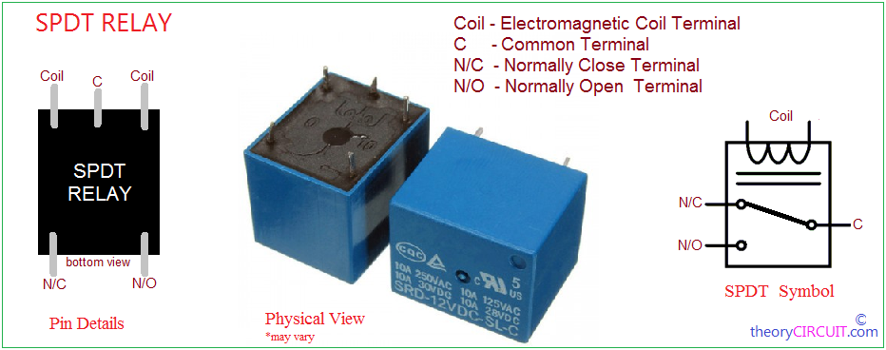

Fig 3.4 Relay Diagram

The relays require suitable pull in current or holding current (around 70MA) to turn it on moreover the relay coil voltage (6volts) is more than what the controller can handle. So, to provide the necessary current & at the required voltage a relay driver circuit is required

Relays are components which are basically used to turn on/off high current or voltage devices a relay is turned on when a sufficient holding current is passed through its coil. We are using 6v spdt relay i.e. the voltage required to energize the coil is 6v and of single Pole Double throw (SPDT) type i.e. it consists of one common pole& two output namely the NO and NC.

**3. Microcontroller**

In this project we have used a microcontroller 89S52.Which is the heart of the project. This controls all the functions of project. The microcontroller 89S52 is used to communicate with the all the function of the Project.

**4. LCD 16X2**

LCD 16x2 display is used to display the information of the user whether the user is authorized or not and also it shows the password is correct or incorrect

It has 1/16 duty cycle. It works on +5v supply and also on +3v.

**5. LM7805**

The MC78XX/LM78XX/MC78XXA series of three terminal positive regulators are available in the TO-220/D PAK package and with several fixed output voltages, making them useful in a wide range of applications. Each type employs internal current limiting, thermal shut down and safe operating area protection, making it essentially indestructible. If adequate heat sinking is provided, they can deliver over 1A output current. Although designed primarily as fixed voltage regulators, these devices can be used with external components to obtain adjustable voltages and currents.

**6. Power Supply**

It is a 3-terminal 1A positive voltage regulator.

**CHAPTER 4**

**COMPONENTS**

**4.1 COMPONENTS OF WIRELESS POWER THEFT MONITORING SYSTEM**

1. 89S52 Microcontroller.
2. Voltage Regulator LM 7805.
3. LCD.
4. Buzzer.
5. Rectifier.
6. NPN Transistor.
7. Crystal Oscillator.
8. Power Supply.
9. PCB Layout.

**4.2 Description of Component**

**4.2.1 Microcontroller 89S52**

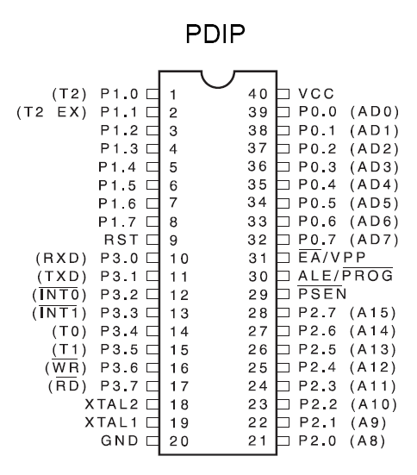

Figure 4.2.1: Microcontroller 89S52

AT89S52 is low-power, high-performance CMOS 8-bit microcontroller with 8K bytes of in-system programmable Flash memory. The device is manufactured using Atmel’s high-density nonvolatile memory technology and is compatible with the industry- standard 80C51 instruction set and pin out. The on-chip Flash allows the program memory to be reprogrammed in-system or by a conventional nonvolatile memory programmer. By combining a versatile 8-bit CPU with in-system programmable Flash on a monolithic chip, the Atmel AT89S52 is a powerful microcontroller which provides a highly-flexible and cost-effective solution to many embedded control applications. The AT89S52 provides the following standard features: 8K bytes of Flash, 256 bytes of RAM, 32 I/O lines, Watchdog timer, two data pointers, three 16-bit timer/counters, a six-vector two-level interrupt architecture, a full duplex serial port, on-chip oscillator, and clock circuitry. In addition, the AT89S52 is designed with static logic for operation Down to zero frequency and supports two software selectable power saving modes. The Idle Mode stops the CPU while allowing the RAM, timer/counters, serial port, and Interrupt system to continue functioning. The Power-down mode saves the RAM contents but freezes the oscillator, disabling all other chip functions until the next interrupt or hardware reset.

**Pin Description**

**VCC-** Supply voltage.

**GND-** Ground.

**Port 0**

Port 0 is an 8-bit open drain bidirectional I/O port. As an output port, each pin can sink

Eight TTL inputs. When 1s are written to port 0 pins, the pins can be used as high

Impedance.

Inputs. Port 0 can also be configured to be the multiplexed low order address/data bus during accesses to external program and data memory. In this mode, P0 has internal pull-ups.

Port 0 also receives the code bytes during Flash programming and outputs the code bytes during program verification. External pull-ups are required during program verification.

**Port 1**

Port 1 is an 8-bit bidirectional I/O port with internal pull-ups. The Port 1 output buffers can sink/source four TTL inputs. When 1s are written to Port 1 pins, they are pulled high by the internal pull-ups and can be used as inputs. As inputs, Port 1 pins that are externally being pulled low will source current (IIL) because of the internal pull-ups. In addition, P1.0 and P1.1 can be configured to be the timer/counter 2 external count input (P1.0/T2) and the timer/counter 2 trigger input (P1.1/T2EX), respectively, as shown in the following table. Port 1 also receives the low-order address bytes during Flash programming and verification.

**Port 2**

Port 2 is an 8-bit bidirectional I/O port with internal pull-ups. The Port 2 output buffers can sink/source four TTL inputs. When 1s are written to Port 2 pins, they are pulled high by the internal pull-ups and can be used as inputs. As inputs, Port 2 pins that are externally being pulled low will source current (IIL) because of the internal pull-ups. Port 2 emits the high-order address byte during fetches from external program memory and during accesses to external data memories that use 16-bit addresses (MOVX @ DPTR). In this application, Port 2 uses strong internal pull-ups when emitting 1s. During accesses to external data memories that use 8-bit addresses (MOVX @ RI), Port 2 emits the contents of the P2 Special Function Register. Port 2 also receives the high-order address bits and some control signals during Flash programming and verification.

**Port 3**

Port 3 is an 8-bit bidirectional I/O port with internal pull-ups. The Port 3 output buffers can sink/source four TTL inputs. When 1s are written to Port 3 pins, they are pulled high by the internal pull-ups and can be used as inputs. As inputs, Port 3 pins that are externally being pulled low will source current (IIL) because of the pull-ups. Port 3 also serves the functions of various special features of the AT89S52, as shown in the following table. Port 3 also receives some control signals for Flash programming and verification.

**RST**

Reset input. A high on this pin for two machine cycles while the oscillator is running resets the device. This pin drives High for 96 oscillator periods after the Watchdog times out. The DISRTO bit in SFR AUXR (address 8EH) can be used to disable this feature. In the default state of bit DISRTO, the RESET HIGH out feature is enabled.

**ALE/PROG**

Address Latch Enable (ALE) is an output pulse for latching the low byte of the address during accesses to external memory. This pin is also the program pulse input (PROG) during Flash programming. In normal operation, ALE is emitted at a constant rate of 1/6 the oscillator frequency and may be used for external timing or clocking purposes. Note, however, that one ALE pulse is skipped during each access to external data memory. If desired, ALE operation can be disabled by setting bit 0 of SFR location 8EH. With the bit set, ALE is active only during a MOVX or MOVC instruction. Otherwise, the pin is weakly pulled high. Setting the ALE-disable bit has no effect if the microcontroller is in external execution mode.

**PSEN**

Program Store Enable (PSEN) is the read strobe to external program memory. When the AT89S52 is executing code from external program memory, PSEN is activated twice each machine cycle, except that two PSEN activations are skipped during each access to external data memory.

**EA/VPP**

External Access Enable. EA must be strapped to GND in order to enable the device to fetch code from external program memory locations starting at 0000H up to FFFFH. Note, however, that if lock bit 1 is programmed, EA will be internally latched on reset. EA should be strapped to VCC for internal program executions. This pin also receives the 12-volt programming enable voltage (VPP) during Flash programming.

**XTAL1**

Input to the inverting oscillator amplifier and input to the internal clock operating circuit.

**XTAL2**

Output from the inverting oscillator amplifier.

**4.2.2 VOLTAGE REGULATOR (7805)**

The LM78** series of three terminal regulators is available with several fixed output voltages making them used in a wide range of applications. One of these on local on card regulation. Eliminating the distribution problems associated with single point regulation. The voltages available allow this regulator to be used in logic system, instrumentation, HiFi& other solid-state electronic equipment. Although design primarily as fixed voltage regulator these devices can be used with external components to obtain adjustable voltages & currents.

The LM78** series is available in an aluminum TO-3 package which will allow over 1.0 A load current if adequate heat sinking is provided. Current limiting is included to limit the peak output current to a safe value. Safe area protection for the output transistor is provided to limit internal power dissipation. If internal power dissipation becomes too high for the heat sinking provided. The shutdown circuit takes over preventing the IC from overheating.

Considerable effort was expanded to make LM78** series of regulators easy to use & minimize the number of external components. It is not necessary, to bypass the output although this does improve transient response. Input bypassing is needed only if the regulator is located far from the filter capacitor of power supply. For output voltage other than 5V, 12V & 15V the LM117 series provided an output voltage range from 1.2V to 57V.

2.1 Features

* Output current is excess of 1 A.
* Internal thermal overload protection.
* No external component required.
* Output transistor safe area protection.
* Internal short circuit current limit.
* Available in the alu3minium TO-3 package.

2.2 Voltage range

* LM7805C
* LM7812C
* **4.2.3. NPN Transistor (BC547)**



Fig.4.2.3 Pin Diagram of NPN Transistor

* **Electrical Characteristics**

|  |  |  |  |  |  |  |
| --- | --- | --- | --- | --- | --- | --- |
| **Symbol** | **Parameter** | **Test condition** | **Min.** | **Typ.** | **Max.** | **Units** |
| ICBO | Collector cut-off Current | VCB=30V, IE=0 |  |  | 15 | nA |
| hFE | DC Current Gain | VCE=5V, IC=2mA | 110 |  | 800 |  |
| VCE(sat) | Collector-Emitter Saturation Voltage | IC=10mA,IB=0.5A  IC =100mA,IB=5mA |  | 90  200 | 250  600 | mV  mV |
| VBE(sat) | Base-Emitter Saturation Voltage | IC=10mA,IB=0.5A  IC=100mA,IB=5mA |  | 700  900 |  | mV  mV |
| VBE(on) | Base-Emitter ON Voltage | VCE=5V, IC=2mA  VCE=5V, IC=10mA | 580 | 660 | 700  720 | mV  mV |
| FT | Current Gain Bandwidth Product | VCE=5V, IC=10mA, f=100MHz |  | 300 |  | MHz |
| Cob | Output Capacitance | VCB=10V, IE=0, f=1MHz |  | 3.5 | 6 | pF |
| Cib | Input Capacitance | VEB=0.5V, IC=0, f=1MHz |  | 9 |  | pF |

Table No. 4.3Electrical Characteristics

**4.4. Liquid Crystal Display**



Fig. No. 4.4 Liquid Crystal Display

A 2 line by 16 Character LCD is Pictured. Data will work on most 1-line x 16 Character, 1 line x 20 Character, 2 line x 16 Character, 2 line x 20 Character, 4linex 20 Character, 2line x 40 1Character etc. modules compatible with the HD44780 LCD module.

**4.5 Pin Description of LCD**

|  |  |  |  |
| --- | --- | --- | --- |
| **Pin no.** | **Name** | **I/O** | **Description** |
| 1 | VSS | Power | GND |
| 2 | VDD | Power | +5V |
| 3 | VO | Analog | Contrast Control |
| 4 | RS | Input | Register select |
| 5 | R/W | Input | Read/write |
| 6 | E | Input | Enable (Strobe) |
| 7 | D0 | I/O | Data LSB |
| 8 | D1 | I/O | Data |
| 9 | D2 | I/O | Data |
| 10 | D3 | I/O | Data |
| 11 | D4 | I/O | Data |
| 12 | D5 | I/O | Data |
| 13 | D6 | I/O | Data |
| 14 | D7 | I/O | Data MSB |

Table No. 4.5.Pin Description of LCD

**4.6 DESIGNING OF POWER SUPPLY**

A) Design of step-downtransformer: -

The following information must be available to the designer of the transformer.

Power output.

Operating voltage.

Frequency range.

Efficiency and regulation.

Size of core is one of the first consideration in regard of weight and volume of a transformer. This depends on type of core and winding configuration used. Generally following formula is used to find Area or Size of the Core.

Ai = √ Wp / 0.87

Where Ai = Area of cross section in square cm.

Wp = Primary Wattage.

For our project we require +5V output, so transformer secondary winding rating is 9V, 500mA.

So secondary power wattage is,

P2 = 9 * 500mA

= 4.5Watt

So,

Ai = √ 4.5 / 0.87

= 2.4

Generally, 10% of area should be added to the core.

So,

Ai = 2.8

a) Turns per volt: - Turns per volt of transformer are given by relation.

Turns per volt = 100000 / 4.44 f * Bm * Ai

Where,

F = Frequency in Hz.

Bm = Density in Wb / Square meter.

Ai = Net area of the cross section.

Following table gives the value of turns per volt for 50 Hz frequency.

|  |  |  |  |  |
| --- | --- | --- | --- | --- |
| Flux density 0.76 Wb /sq. m | 1.14 | 1.01 | 0.91 | 0.83 |
| Turns per Volt  45 / Ai | 40 / Ai | 45 / Ai | 50 / Ai | 55 / Ai |

Table no.4.6. Value of turns per volt for 50 Hz frequency.

Generally, lower the flux density better the quality of transformer. For our project we have taken the turns per volt is 0.91 Wb / sq.m from above table.

Turns per volt = 50 / Ai

= 50 / 2.8

= 17.85

Thus, the turns for the primary winding is,

220 * 17.85 = 3927

And for secondary winding,

9 * 17.85 = 160

b) wire size: - As stated above the size is depends upon the current to be carried out by winding which depends upon current density. For our transformer one tie can safely use current density of 3.1 Amp / sq.mm.

for less copper loss 1.6Amp/sq.mm or 2.4sq.mm may be used generally even size gauge of wire are used.

R.M.S secondary voltage at secondary to transformer is 9V. so maximum voltage Vm across secondary is

= 9 * 1.141

= 12.727v

D.C output voltage Vm across secondary is,

Vdc = 2 * Vm/pi

= 2 * 12.727/3.14

= 8.08 V

P.I.V rating of each diode is

PIV = 2Vm

= 2 * 8.08

= 16.16 V

Maximum forward current, which flow from each diode is 500 mA. So from above parameter, we select diode IN4007 from the diode selection manual.

B) Design of filter capacitor

Formula for calculating filter capacitor is

C = ¼ √3 r * F * R1

Where,

r = ripple present at output of rectifier, which is maximum 0.1 for full wave rectifier.

F = frequency of AC main.

R1 = input impedance of voltage regulator IC

C = ¼ √ 3 * 0.1 * 50 * 28

= 1030 µf

= 1000 µf

Voltage rating of filter capacitor should be greater than the i/p Vdc i.e. rectifier output which is 8.08 V so we choose 1000µf / 25V filter capacitor

C) Specification of voltage regulator IC: -

|  |  |
| --- | --- |
| Parameter | Rating |
| Available output DC voltage. | +5V |
| Line regulation. | 0.03 |
| Load regulation. | 0.5 |
| Vin maximum. | 16.16 V |
| Ripple rejection. | 60-80db |

Table no. 4.7. Specification of voltage regulator IC

**4.7 sim900a gsm module**

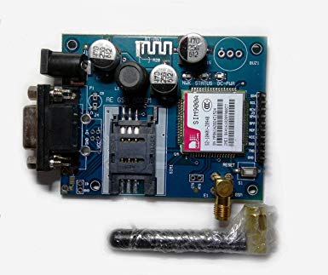

**PRODUCT DESCRIPTION**

Overview

GPRS module is a breakout board and minimum system of SIM900 Quad-band/SIM900A Dual-band GSM/GPRS module. It can communicate with controllers via AT commands (GSM 07.07 ,07.05 and SIMCOM enhanced AT Commands). This module supports software power on and reset.

**Features**

* Quad-Band 850/ 900/ 1800/ 1900 MHz
* Dual-Band 900/ 1900 MHz
* GPRS multi-slot class 10/8GPRS mobile station class B
* Compliant to GSM phase 2/2+Class 4 (2 W @850/ 900 MHz)
* Class 1 (1 W @ 1800/1900MHz)
* Control via AT commands (GSM 07.07 ,07.05 and SIMCOM enhanced AT Commands)
* Low power consumption: 1.5mA(sleep mode)
* Operation temperature: -40°C to +85 °C

**4.8 Components used in Circuit**

**Resistor**

Resistor is as passive component.

Symbol

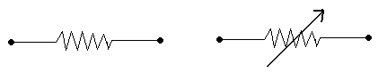

A resistor creates resistance in a circuit the resistance is measure in ohm is the basic unit of resistance. The resistor are used to be chopped the current.

**Construction of resistor**

A simple resistor can be constructed using a resistive materials wire by winding it on an insulating road.

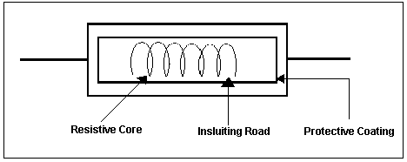

Such type of resistor is known as wire wound resistor. The other types of resistor are MFR&CFR.

MFR&CFR resistor has a central insulating resistor road which is lipped in a metal oxide and are solder to protect after fitted at the hand to well leads are solder a protect. Coding us applied on the resistor & the colors code ringing are point a coding to the value of resistor.

**Capacitor**

Capacitor is a passive component.

Symbols

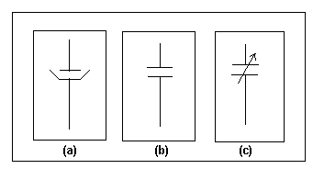

Electrolytic capacitor.

Fixed capacitor.

Variable capacitor.

**Construction**

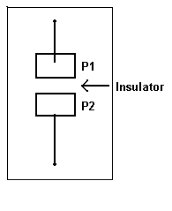

A simple capacitor consists of two material plates in fronts of each other with a small gap between the two plates. Metal leads are soldering to the two plates. The gap between the plates consists of air or any other insulation materials known as Di-electric material.

Working: When DC supply is applied between the two plates P1&P2 a charge is produce along the surface of the plates that can be stored between these plates for some time which is known as capacitance. This capacitance is measure in unit fared (f).

**Factor on which the value of capacitor IS depend.**

1) Distance between two plates.

2) Over lapping area of the plates.

Di-electric material use

**DIODE**

Diode is semiconductor component.

Symbol

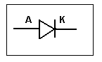

**Semiconductor**

Semiconductors are the substance having the electrical conductor intermediate to that of good conductor and insulators.

Example: Silicon, germanium etc.

**N-Type semiconductor:** A semiconductor dope with a pentavalent impurity like arsenic or anti moles has conductivity due to negatively charged electron such semiconductor doped with pentavalent impurity is called as N type semiconductor.

**P- Type semiconductor:** A semiconductor dope with a trivalent impurity like indium or aluminum has conductivity due to holes that are positive charge carriers such semiconductor dope with trivalent impurity is called a p type semiconductor.

P-N Junction: If a p type semiconductor is joined to an N-type of semiconductor then the boundary joining the two regions is called a P-N junction diode or a semiconductor diode.

**TRANSISTOR**

Symbol

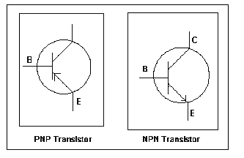

Transistor: A transistor is a three terminal semiconductor device it is mode by sand witch in a thin slice of N type semiconductor between two P type semiconductors of a thin slice of P type semiconductor between N type semiconductors.

**Types of transistor**

**1) PNP Transistor:** In this transistor a thin layer an N type semiconductor is sand between two layers of P type semiconductor.

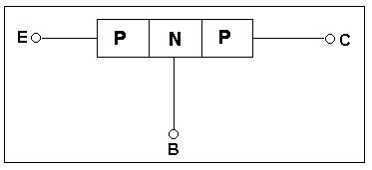

**2)NPN Transistor:** In this transistor a thin layer of P type send conductor is sand between two N type semiconductors.

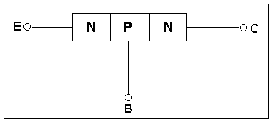

The central thin layer of transistor is called the base (B) one of the end layer is called an emitter (E) and the other is called collator(C).

**LED (Light Emitting Diode)**

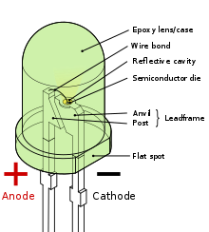

Fig 4.7 Light Emitting Diode

Just like a PN junction can observe light and produce an electrical current. The opposite is also possible that means junction diode can also emit light or exhibits electro luminescence. The LED is a PN junction device, which emits light when current passes through it in forward direction. The emitted light in the case comes from hole-electron pair recombination. When a free electron recombines it falls higher energy level to ground level state and light is given off at a wavelength corresponding to energy level difference associated with transition.

By using elements like gallium, arsenic and phosphorus, the LED’s can be manufactured to radiate red, green, yellow, orange and invisible infrared rays. LED’s that radiate visible radiation are used in instrument displays such as calculators, digital watches, panel meters etc.

SPECIFICATIONS:

It requires 10-1250 mw power

Gives off visible light when it is energized

Forward voltage is 1.5 V.

FEATURES:

Size: 2mm, 3mm, 5mm, 10mm

Shape: Round, square, Rectangle

Color’s: Red, Green, Yellow, Blue, Orange.

**CHAPTER 5**

**PCB DESIGNING**

**5.1 Designing of PCB: Printed Circuit Board (PCB)**

In electronic system it would be virtually impossible for package without in corpora tin printed circuit in their design. Printed circuit is metal foil conducting pattern serves as the connection medium for the electronic medium that are assumable on the opposite side of the board.

Conducting materials available are silver, brass, aluminum, & copper. Copper is most widely used. The thickness of conducting material depends upon the current carrying capacity of circuit thus a thicker copper layer will have more current carrying capacity,

1. It provides mechanical support for the components mounted on it.

2. It provides necessary electrical interconnection.

3. It acts as the heat sink i.e. it provides a conduction path leading to removal of most of the heat generated in the circuit.

**Advantages of PCB**

* When a number of identical assemblies are required PCBs provide cost saving because once a layout is approved there is no need to check the circuit every time.
* For large equipment’s such as computer the saving on checking connections or wires is substantial.
* PCBs have controllable and predictable electrical and mechanical properties.
* A more uniform product is produced because writing errors are eliminated.
* The distributed capacitance is constant from one production to another.
* Soldering is done in one operation instead of one connection discrete component by wires.
* The PCB construction land itself for automatic assembly.
* Spiral type of inductors may be printed.
* Weight is less.
* It has miniaturization potential.

All the signals are accessible for testing it at any point along the conductor track.

Current carrying capacity depends upon the track with. Due to high currents there is temperature raise caused in conductors.

Ideally, under normal working conditions there should not temperature raise in conductors. When two conductors are running parallel to each other, depending upon the dielectric constant eliminate their exit certain capacitors. Similar in double sided boards. When track is either side of boards there is capacitance as two tracks are considered to metal conductor with laminate as dielectric. Mechanical considerations have to take on account like heavy components like transformer may be given separate mechanical support. The number of jumper should be minimum. Heat sensitive components must be kept away from the heat producing one’s Sufficient test points must be given and components must easy accessibility for replacement. When two signal lines are running close to each other is possibly of cross take. To reduce this, an electromagnetic interference all unused copper surfaces are connected to ground line is made sufficiently broad. Normally low power and high-power level wire are twisted outside PCB to protect the circuit from the electromagnetic coupling.

**5.2 LAYOUT**

Layout designing is the pencil sketch of component and conductors drawing which contain all relevant information for preparation of artwork. Layout is designed is the pencil sketch of component and conductor drawing which contain all relevant information for preparations of artwork. Layout is designed on tracing paper for better accurate.

**5.3 ETCHING**

Removal of unwanted copper, to give final copper pattern as ETCHING solutions, which are using on Etching, is known as enchant.

Ferric chloride

Cupric chloride

Chronic ac

Alkaline ammonia

Out of these ferric acids is widely used because it has short etching time and it can be stored for longer time rising follow etching.

**5.4 SOLDERING**

It is the process in which the components and the connecting tracks get in join firmly. We used 25-watt soldering iron and flux coated soldering wire. The solder which is to be applied to the till the gap of joints is placed close to the iron bit. It immediately melts and become bright and fluid. Enough soldering was applied to fill up the gap of the joints to give good strength and conductivity to the connections. When the joint happens to be sufficiently filled with the soldering irons removed and the joints are allowed to cool down. After soldering PCB is cleaned and made free from dust. All the connection is checked with the help of the multi-meter (AVO).

The dry soldering or short connections are done. Now wiring flexible multicore wire of require gauge, the wiring is completed. First the wires are cut down into the sufficient length. The inside core and connections are cleared and soldered connections are checked with multimeter (AVO).

Fluxes are auxiliary materials used while soldering is done.

They dissolve and remove oxide and contain elements from the surface of metal to solder.

They protect the metal surface and molten soldered from oxidation.

They reduce the surface tension of motion solder.

They improve the ability of solder to wet the metal.

**5.5 TESTING & TROUBLE SHOOTING**

TESTING:

Testing is nothing but the physical checking of the all components and all possible condition to avoid problem in the circuit functioning. Testing done with so many checking instruments as per the circuit requirement and conditions.

BARE BOARD TESTING:

In bare board testing we should have to check the following points Continuity of the track over etching or under etching if any Shorts if any VCC and GND tracks

TROUBLE SHOOTING:

After the PCB is prepared the conductivity test is carried out. First pin-to-pin conductivity is checked. The necessary IC interconnections are also checked. The resistance value of all the resistor are checked and then completed with the value denoted by color-coding is done.

The capacitors are also checked to see whether they are working or short or open. The diodes are tossed for priority. The diodes are cracked for their forward resistance and reverse resistance. After carrying out all the possible testing, the jumper wires are also tested for conductivity.

**5.6. PCB Layout**

**5.6.1 PCB Layout of Main Board**

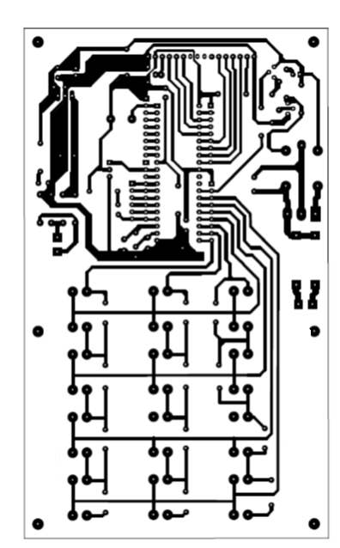

**Fig. No. 5.6.1 PCB Layout of Main Board**

This device can be used with external components to obtain variable voltage and current.

It is used to supply the power to AT2051 and microcontroller, LCD, etc

**CHAPTER 6**

**RESULT**

**6.1 Result and Analysis**

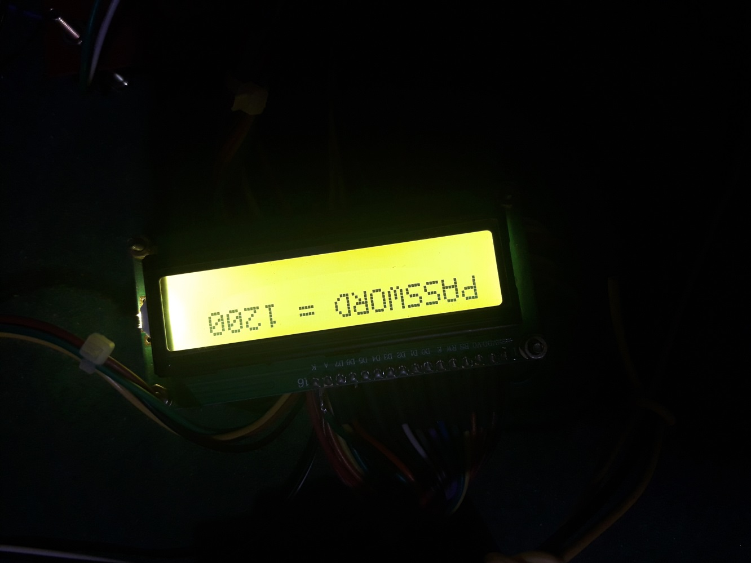This proposed system provides a solution, which can ensure the safety of the maintenance staff e.g. line man. The control to turn ON/OFF the line lies with the line man only. This system has an arrangement such that a password is required to operate the circuit breaker (ON/OFF). Line man can turn off the supply and comfortably repair it, and return to the substation, then turn on the line by entering the correct password. Since it has the provision of changing the password, person can give any password of his will and have his work done safer.

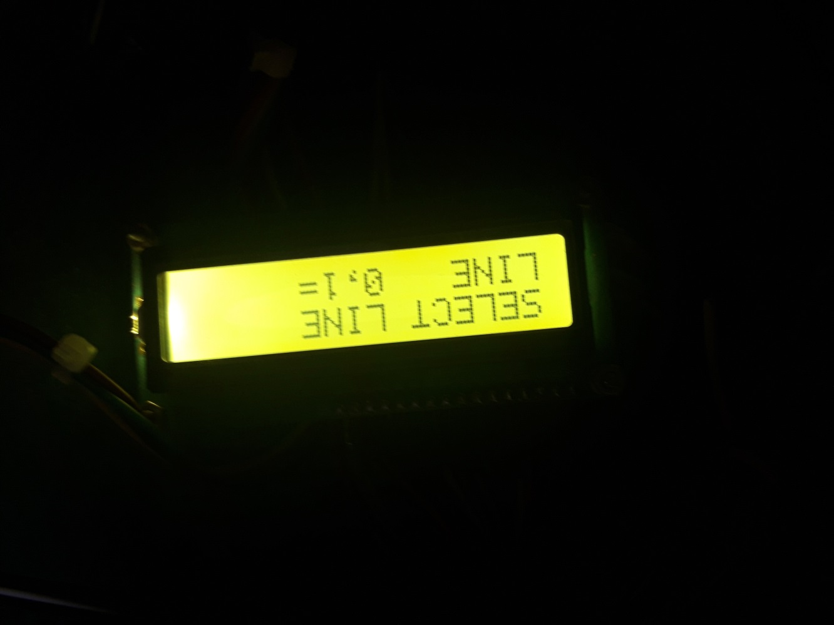

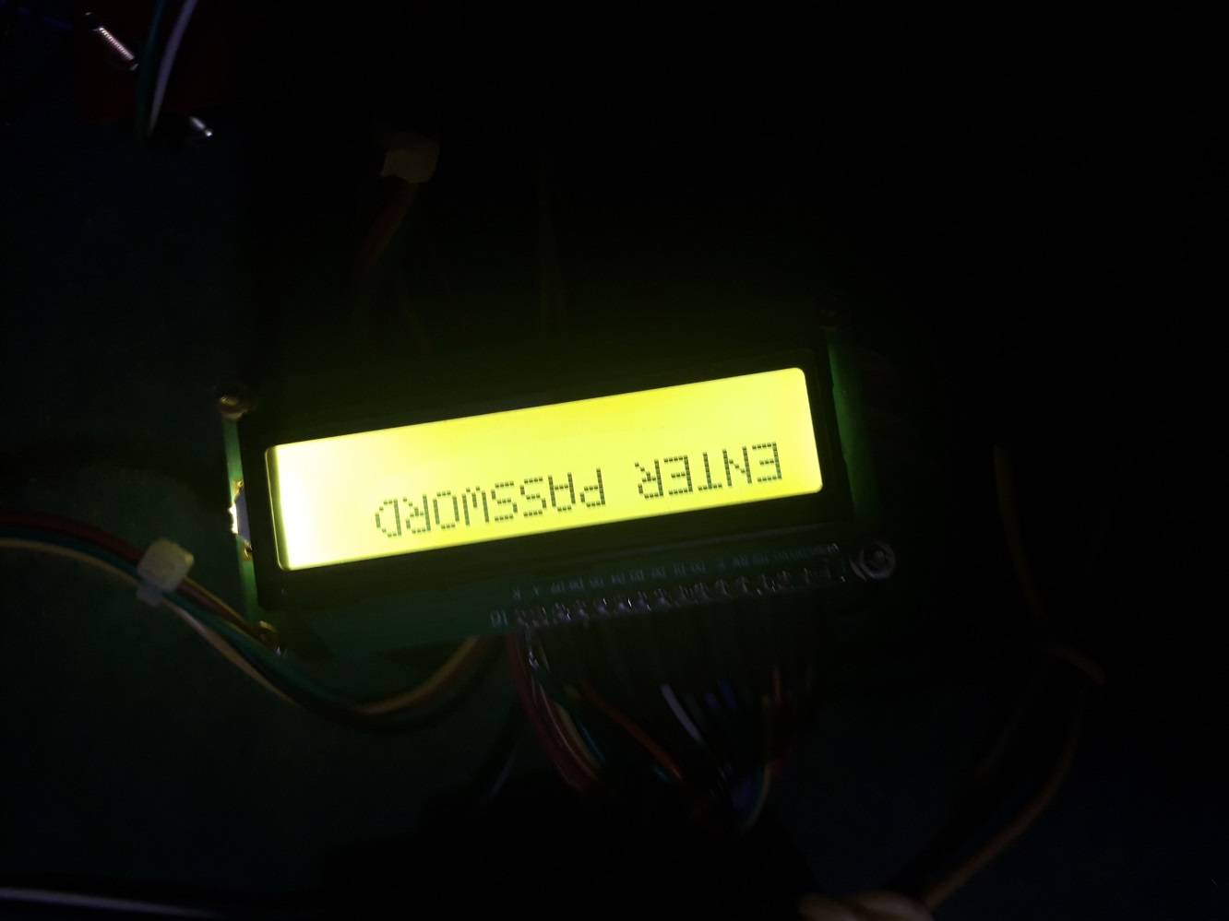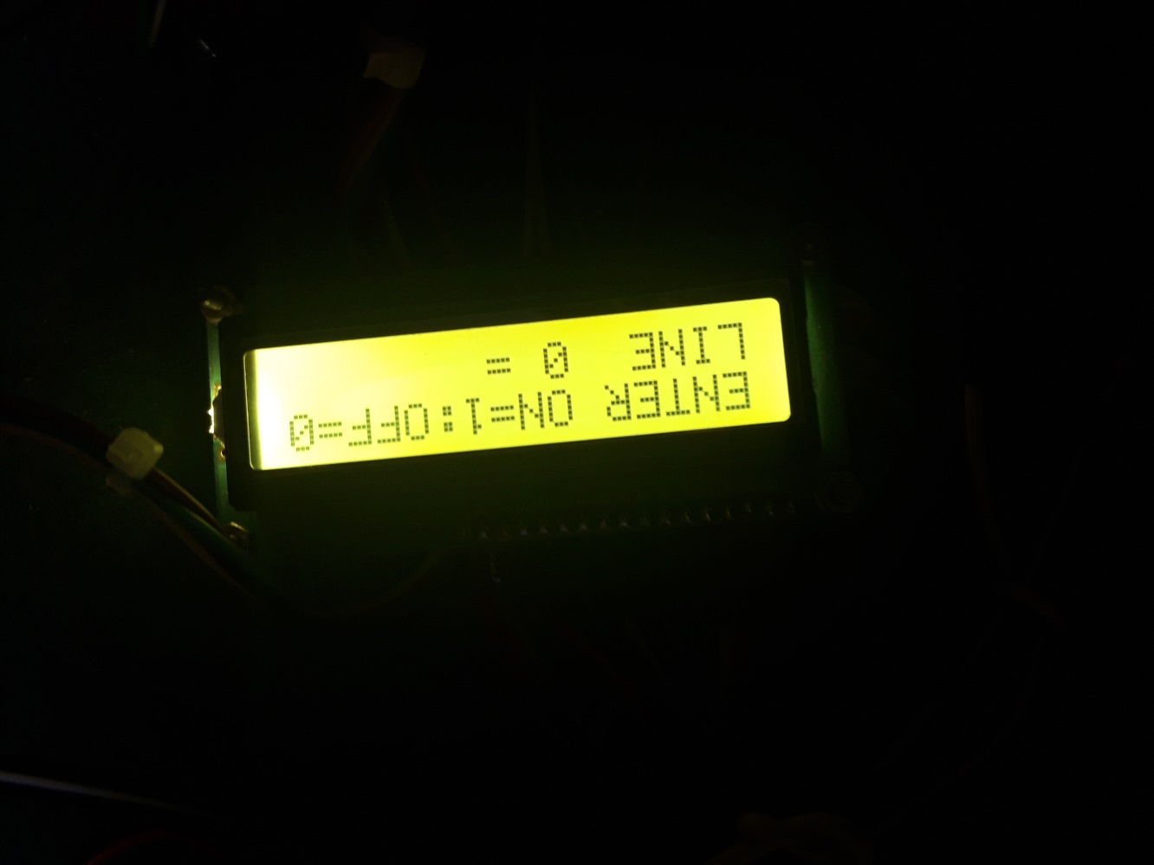

**CHAPTER 7**

**LIST OF MATERIAL AND COST**

**7.1. Estimated Cost of Each Equipment’s**

|  |  |  |  |
| --- | --- | --- | --- |
| **Name of equipment** | **Quantity** | **Price** | **Total** |
| Step down Transformer | 1 | 130 | Rs.130 |
| PCB | 1 | 90 | Rs.90 |
| PCB | 3 | 50 | Rs.150 |
| LCD | 1 | 175 | Rs.175 |
| Microcontroller | 1 | 160 | Rs.160 |
| Rectifier | 1 | 25 | Rs.25 |
| Crystal Oscillator | 1 | 10 | Rs.10 |
| Capacitor | 1 | 6 | Rs.6 |
| Total |  |  | Rs. 2246 |

|  |  |  |  |  |
| --- | --- | --- | --- | --- |
| Comment | Designator | Footprint | Quantity | Cost |
| Small Buzzer | B1 | BZ20S | 1 | 15 |
| 0.1Uf | C1, C7 | RAD0.1 | 2 | 2 |
| 10Uf | C2 | LED | 1 | 5 |
| 470uF/16v | C3 | RB.2/.4 | 1 | 15 |
| 33PF | C4, C5 | RAD0.1 | 2 | 2 |
| 10uF/25V | C6 | LED | 1 | 15 |
| 1000uF/25V | C8 | RB.2/.4 | 1 | 20 |
| 2PIN CONNECTOR | CON1 | POWER4 | 1 | 10 |
| 3PIN CONNECTOR | CON2 | SIP3 | 1 | 5 |
| 6 pin rely mate con | CON3 | SIP9 | 1 | 5 |
| 16 PIN RELYMATE | CON4 | SIP16 | 1 | 15 |
| CON10 | CON5 | SIP3 | 1 |  |
| 2 PIN CONNECTOR | CON6 | POWER4 | 1 | 2 |
| IN4007 | D1, D2, D3, D4, D5 | DIODE0.4 | 5 | 10 |
| IN5408 | D6, D15 | DIODE0.7 | 2 | 4 |
| 40 PIN IC BASE | IC1 | DIP40 | 1 | 55 |
| OMRON KEY | K1, K2, K3, K4, K5, K6, K7, K8, K9, K10, K11, K12 | PB-KEY | 12 | 60 |
| RED LED | L1 | LED | 1 | 2 |
| GREEN | L2 | LED | 1 | 2 |
| RED | L3 | LED | 1 | 2 |
|  | O/P1 | SIP2 | 1 |  |
| 10K | P1 | PRESET | 1 | 15 |
| BC557 | Q1 | TO-92A | 1 | 8 |
| BC547 | Q2 | TO-92A | 1 | 8 |
| 1K | R1, R2, R5, R7, R8 | AXIAL0.4 | 5 | 5 |
| 10K | R3 | AXIAL0.4 | 1 | 1 |
| 50E | R4 | AXIAL0.4 | 1 | 1 |
| 4.7K | R6 | AXIAL0.4 | 1 | 1 |
| LM7805 | REG1 | T0-220WH | 1 | 15 |
| 5V RELAY SPDT | RELAY1 | PCB_RLY | 1 | 25 |
| 10K 9PIN | RPACK1, RPACK2 | SIP9 | 2 | 10 |
| 10K/9PIN | RPACK3, RPACK4 | SIP9 | 2 | 10 |
| TACTILE KEY | SW1, SW2, SW3, SW4, SW5, SW6, SW7, SW8, SW9, SW10, SW11, SW12 | RST_KEY | 12 | 60 |
| 11.059MHz | X1 | XTAL1 | 1 | 40 |

Table No. 7.1 Estimated Cost of Each Equipment’s

**CHAPTER 8**

**ADVANTAGES AND DISADVANTAGES**

**8.1 Advantages**

* Machine will be secure
* Unauthorized person will not able to on the device
* The important document will be safe
* Our electronic door lock performed as expected. We were able to implement all of the functions specified in our proposal. The biggest hurdle we had to overcome with this project was interfacing the micro controller with the hardware components. We feel that this electronic door lock is very marketable because it is easy to use, comparatively inexpensive due to low power consumption, and highly reliable.

**8.2 Disadvantages**

* The circuit is bulky.
* The programming is complicated.
* The circuit is complicated.
* High cost
* Slow speed of circuits

**8.3 Application**

* It can be used to protect any thing
* It can be used in bank locker
* It can be used to turn on an of the industrial machines
* It is used in army station
* It is used for the war
* It can used to control home appliances.

**CHAPTER 9**

**CONCLUSION**

* 1. **Conclusion**

This project proposed an architecture based on Password based wireman safety system in India.The syastem design mainly concentrates on single phase distribution system., espitially suited for Indian scenario. The proposed system provides the solution for some of the main problems faced by the existing Indian machine security system, such as wastage of energy, power theft, mannual CNC systam and transmission line fault. In future, we plan to implement this design and validate it in our remote area. We will also incorporate future anhancement to suit the system for thre phase4 electric distribution system in India. Along with all these new architectural componenets will be incorporated.

**CHAPTER 10**

**FUTURE SCOPE**

**10.1 Future scope**

* Electrical devices such as Lights, Computer etc. can be controlled by using separate passwords.
* The system can be easily connected to the personal computer for further control.
* The system can be made touch screen
* System could be made more secure

**CHAPTER 11**

**REFERENCES**

**11.1 References**

[1] A. R. Devidas, M. V. Ramesh. "Wireless Smart Grid Design for Monitoring and Optimizing Electric Transmission in India," IEEE 2010 Fourth International Conference on Sensor Technologies and Applications.

[2] "Electrical Power Supply System for India,” www.wikipedia.org, February 2010

[3] "Smart Grid," www.wikipedia.org.

[4] Ajay Deshmukh “The Microcontroller Theory & Applications” Tata McGraw-Hill Publication.

[5] “National Electricity Policy,” The Gazette of India, EXTRAORDINARY PART 1-Section 1, Ministry of Power. New Dhelhi, Dated the 12th, Februvary, 2005, RSOLUTION No. 23/40/2004-R & R (Vol.2).

[6] “Electricity Crisis in India, “www.ElectricityInIndia.com.

[7] S. N. Singh, “Electric Power Generation, Transmission and Distribution”, 2nd ed. Prentice-Hall of India Private Limited, 2003.

[8] “Electrical Power Supply System for India”, [www.wikipedia.org](http://www.wikipedia.org),

February-2010

------------------------------------------*-----*-----*-------------------------------------------